CERTIFICATE OF ORDER

THE STATE OF TEXAS §
COUNTY OF HARRIS §
HARRIS COUNTY WATER CONTROL AND IMPROVEMENT DISTRICT NO. 99 §

We, the undersigned officers of the Board of Directors (the "Board") of HARRIS COUNTY WATER CONTROL AND IMPROVEMENT DISTRICT NO. 99 (the "District"), hereby certify as follows:

The Board convened in special session, open to the public, on Tuesday, July 24, 2019, at 3:00 p.m., at 19423 Lockridge Drive, Spring, Texas, and the roll was called of the members of the Board, to-wit:

 | Monte Cooper |  | President
 | Billy Ray Fritsche |  | Vice President
 | Ed Jensen |  | Secretary/Treasurer/Investment Officer
 | Tim Evans |  | Assistant Secretary
 | Charles L. Richardson |  | Director/Records Management Officer

All members of the Board were present except, the following _____Jensen, Evans__________, thus constituting a quorum. Whereupon other business, the following was transacted at such Meeting: A written

ORDER CALLING BOND ELECTION AND
OPERATION AND MAINTENANCE TAX ELECTION

was duly introduced for the consideration of the Board. It was then duly moved and seconded that such Order be adopted; and after full discussion, such motion, carrying with it the adoption of such Order prevailed, carried, and became effective by the following vote:

 | AYES: | 3 | NOES: | 0 | ABSTAIN: | 0

A true, full and correct copy of the aforesaid Order adopted at the Meeting described in the above and foregoing paragraph is attached to and follows this Certificate; such Order has been duly recorded in the Board's minutes of such Meeting; the above and foregoing paragraph is a true, full, and correct excerpt from the Board's minutes of such Meeting pertaining to the adoption of such Order; the persons named in the above and foregoing paragraph are the duly chosen, qualified, and acting officers and members of the Board as indicated therein; each of the officers and members of the Board are duly and sufficiently notified officially and personally, in advance, of the time, place, and purpose of such Meeting, and that such Order would be introduced and considered for adoption at such meeting, and each of the officers and members consented, in advance, to the holding of such Meeting for such purpose; and such Meeting was open to the public and public notice of the time, place, and purpose of such Meeting was given, all as required by Chapter 551 of the Texas Government Code, and Section 49.063 of the Texas Water Code, as amended.

SIGNED this __13th_ day of August 2019.

/s/ Ed Jensen /s/ Monte Cooper

Secretary, Board of Directors President, Board of Directors

(DISTRICT SEAL)
ORDER CALLING BOND ELECTION AND
OPERATION AND MAINTENANCE TAX ELECTION

THE STATE OF TEXAS §
COUNTY OF HARRIS §
HARRIS COUNTY WATER CONTROL AND IMPROVEMENT DISTRICT NO. 99 §

WHEREAS, HARRIS COUNTY WATER CONTROL AND IMPROVEMENT DISTRICT NO. 99 (the "District"), located in Harris County, Texas, is a political subdivision of the State of Texas, organized, created, and established pursuant to an order of the Texas Water Commission, statutory predecessor to the Texas Commission on Environmental Quality, dated July 29, 1966, and operates in accordance with the Texas Water Code, Chapters 49 and 51.
WHEREAS, pursuant to Section 49.4645, Texas Water Code, the District has the authority to call an election for the issuance of bonds to be repaid from the imposition of an annual ad valorem tax on all property within the boundaries of the District, and therefore, the Board desires to call such an election to be held in conjunction with the elections described herein;
ISSUANCE OF BONDS AND REFUNDING BONDS
FOR WATERWORKS SYSTEM, AND SANITARY SEWER SYSTEM
WHEREAS, as required by Section 49.106, Texas Water Code, there has been filed in the office of the District, open to the inspection by the public, an engineer's report covering the works, land, improvements, facilities, plants, equipment and appliances to be purchased, constructed, acquired, owned, operated, repaired, or extended by the District (the "Improvements"), and the property, administrative facilities, contract rights, rights of use and interest in property, and regional, regulatory or joint use participation rights to be purchased or acquired, as well as the estimated probable costs of all of the foregoing, together with maps, plats, profiled and/or data showing and explaining the report (the "Engineering Report"); and
WHEREAS, the Board finds that the estimates of probable costs of the design, construction, repair, extension, purchase, and acquisition of waterworks system, sanitary sewer system and drainage facilities, and incidental expenses connected with such improvements and the issuance of bonds and refunding bonds, contained in the Engineering Report are reasonable and proper and hereby approves the same; and
WHEREAS, such Engineer's Report includes an estimate of the probable costs of the design, construction, repair, extension, purchase, and acquisition of the Improvements and additional thereto, and incidental expenses connected with the Improvements and the issuance of bond by the District, attached hereto as Exhibit "A":

EXHIBIT A
Harris County Water Control & Improvement District No. 99
Bond Issue Authority Summary
7/24/2019
Construction Costs
A. | District Improvements, Water, Sewer and Drainage
 |  |  |  |  |  |  |  | $ 7,616,813.00
 |  | Contingencies at 15% |  |  |  |  |  | $ 1,142,521.95
 |  | Engineering, Surveying, Geotechnical & Inspection at 20% |  |  |  |  |  | $ 1,751,866.99
 | District Improvements Total |  |  |  |  |  |  | $ 10,511,201.94
B. | Purchased Facilities and Expenses
 | Purchased Facilities and Expenses Total |  |  |  |  |  |  | $1,030,200.00
A. | District Improvements Total |  |  |  |  |  |  | $ 10,511,201.94
B. | Purchased Facilities and Expenses Total |  |  |  |  |  |  | $ 1,030,200.00
 | Total Construction Costs |  |  |  |  |  |  | $ 11,541,401.94
Non-Construction Costs |  |  |  |  |  |  |  | $1,399,094.82
Bond Issue Requirement (BIR)
I. | Total Construction Costs |  |  |  |  |  |  | $ 11,541,401.94
II. | Non-Construction Costs |  |  |  |  |  |  | $ 1,399,094.82
 | Total Bond Issue Requirement (BIR) |  |  |  |  |  |  | $ 12,940,496.76
 | Inflation of 3.0% for 15 years |  |  |  |  |  |  | $ 3,059,503.24
 | Final Bond Issue Requirement |  |  |  |  |  |  | $ 16,000,000.00

WHEREAS, the costs are estimates only and the Improvements and the costs thereof may change based upon actual requirements as development occurs within the District; and
WHEREAS, the Board finds and determines that said total estimate of $16,000,000 for a waterworks system, sanitary sewer system and drainage facilities is reasonable and proper and will be sufficient for the aggregate costs to provide the Improvements and additions thereto, and incidental expenses connected with the Improvements and the issuance of bonds and refunding bonds; and
WHEREAS, the Board further desires to call an election for the purpose of submitting a proposition on the issuance of the bonds and refunding bonds of the District for the provision of a waterworks system, sanitary sewer system and drainage facilities in the maximum aggregate principal amount of $16,000,000 and the levy of taxes in payment of such bonds; and
WHEREAS, it is anticipated that the gross revenues from the District's water and sewer system may not be sufficient to provide funds for maintenance purposes, including funds for planning, constructing, acquiring, maintaining, repairing, purchasing, extending and operating all necessary land, plants, works, facilities, improvements, appliances and equipment of the District and for paying costs of proper services, engineering and legal fees, and organization and administrative expenses; and
WHEREAS, the Board of the District finds and determines that it will be in the best interest of the District to obtain authorization for the levy and collection of an additional operations and maintenance tax upon all taxable property within the District, for purposes of providing operation and maintenance revenues for District projects, pursuant to Section 49.107, Texas Water Code; and
WHEREAS, the Board of the District has determined that it is in the best interest of the District to call an operation and maintenance tax election for the next uniform election date not to exceed 40 cents ($0.40) per one hundred dollars ($100) valuation of taxable property, which is Tuesday, November 5, 2019; and
WHEREAS, the Board, in an open, public meeting, proper notice of which has been as required by law, has given consideration to calling a bond election and operation and maintenance tax election for November 5, 2019 (collectively, the "Election"); and
WHEREAS, the Board of the District deems it necessary and appropriate to establish the procedures whereby such Election may be held; and
WHEREAS, the Board wishes to proceed with the ordering of the Election.
NOW, THEREFORE, BE IT ORDERED BY THE BOARD OF DIRECTORS OF HARRIS COUNTY WATER CONTROL AND IMPROVEMENT DISTRICT NO. 99 THAT:

The matters and facts set out in the preamble of this Order are hereby found and declared to be true and complete.

The Engineering's report and estimates of costs described and attached hereto as Exhibit "A" above are hereby found and declared to be true and complete and has been approved by the Board.

Such Election shall be held and conducted in all respects as provided by law for general elections, except as provided by Chapter 49, Texas Water Code, as amended.

An election shall be held between the hours of 7:00 a.m. and 7:00 p.m., on the 5th day of November, 2019 at 19423 Lockridge Drive, Spring, Harris County, Texas 77373, a place within the District, and the boundaries of the District are hereby established as, and shall constitute one (1) election precinct for the Election.

The Board hereby designates its Attorney, Johnson Petrov LLP ("Attorney"), 2929 Allen Parkway, Suite 3150, Houston, Texas 77019, as authorized representative for purposes of the Election, and any and all documents required to be filed with or notices required to be given by the Secretary of the Board under the provisions of the Texas Election Code shall be deemed filed and notices shall be deemed given if filed with or given to the Board's Attorney.

The following proposition shall be submitted to the resident electors of the District:
PROPOSITION A
SHALL THE BOARD OF DIRECTORS (THE "BOARD") OF HARRIS COUNTY WATER CONTROL AND IMPROVEMENT DISTRICT NO 99 (THE "DISTRICT") BE AUTHORIZED TO ISSUE BONDS OF SAID DISTRICT IN ONE OR MORE ISSUES OR SERIES IN THE MAXIMUM ORIGINAL PRINCIPAL AMOUNT OF $16,000,000 MATURING SERIALLY OR OTHERWISE OVER A PERIOD NOT TO EXCEED 40 YEARS FROM THEIR DATE OR DATES, AND TO BE ISSUED AND SOLD AT ANY PRICE OR PRICES AND TO BEAR INTEREST AT ANY RATE OR RATES AS SHALL BE DETERMINED WITHIN THE DISCRETION OF THE BOARD OF THE DISTRICT AT THE TIME OF ISSUANCE AS AUTHORIZED BY LAW AS NOW ENACTED OR HEREAFTER AMENDED, FOR THE PURPOSES OF (A) FINANCING THE DESIGN, CONSTRUCTION, REPAIR, EXTENSION, PURCHASE AND ACQUISITION OF THE DISTRICT'S WATERWORKS SYSTEM, SANITARY SEWER SYSTEM AND DRAINAGE FACILITIES, AND (B) THE REFUNDING OF ANY BONDS OR OTHER EVIDENCES OF INDEBTEDNESS OF THE DISTRICT WHICH MAY BE OUTSTANDING FROM TIME TO TIME IN THE MAXIMUM AMOUNT NOT TO EXCEED ONE AND ONE-HALF (1½) TIMES THE AMOUNT OF BONDS OR INDEBTEDNESS ISSUED FOR ANY LAWFUL PURPOSE OF THE DISTRICT, AND TO PROVIDE FOR THE PAYMENT OF PRINCIPAL OF AND INTEREST ON SUCH BONDS BY THE LEVY AND COLLECTION OF A SUFFICIENT TAX UPON ALL TAXABLE PROPERTY WITHIN SAID DISTRICT, ALL AS AUTHORIZED BY THE CONSTITUTION AND LAWS OF THE STATE OF TEXAS?

PROPOSITION B

SHALL THE BOARD OF DIRECTORS (THE "BOARD") OF HARRIS COUNTY WATER CONTROL AND IMPROVEMENT DISTRICT NO 99 (THE "DISTRICT") BE AUTHORIZED TO LEVY AN OPERATION AND MAINTENANCE TAX AT A RATE NOT TO EXCEED 40 CENTS ($0.40) PER ONE HUNDRED DOLLARS ($100) VALUATION OF TAXABLE PROPERTY TO PROVIDE FUNDS FOR OPERATION AND MAINTENANCE PURPOSES, INCLUDING PLANNING, CONSTRUCTING, ACQUIRING, MAINTAINING, REPAIRING, PURCHASING, EXPENDING, AND OPERATING ALL NECESSARY LAND, PLANTS, WORKS, FACILITIES, IMPROVEMENTS, APPLIANCES AND EQUIPMENT OF THE DISTRICT AND FOR PAYING COSTS OF PROPER SERVICES, ENGINEERING AND LEGAL FEES AND ORGANIZATION AND ADMINISTRATIVE EXPENSES, ALL AS AUTHORIZED BY THE CONSTITUTION AND LAWS OF THE STATE OF TEXAS.

Voting in the election for the proposition shall be by the use of electronic or paper ballot which shall be printed in English, Spanish, Vietnamese, and Chinese and which shall conform to the requirements of federal law, including the Help America Vote, and the Texas Election Code, as amended. The order of the propositions on the ballot shall be in accordance with the Texas Election Code. The ballots used in the election shall contain the following.
OFFICIAL BALLOT
PROPOSITION A

( )  ( ) | FOR  AGAINST | )  )  ) | THE ISSUANCE OF $16,000,000 BONDS FOR THE DESIGN, CONSTRUCTION, REPAIR, EXTENSION, PURCHASE AND ACQUISITION OF THE DISTRICT'S WATERWORKS SYSTEM, SANITARY SEWER SYSTEM AND DRAINAGE FACILITIES, THE LEVY OF TAXES ADEQUATE TO PROVIDE FOR PAYMENT OF THE BONDS, AND THE REFUNDING OF ANY OUTSTANDING BONDS
PROPOSITION B
( )  ( ) | FOR  AGAINST | )  )  ) | AN OPERATION AND MAINTENANCE TAX NOT TO EXCEED 40 CENTS ($0.40) PER ONE HUNDRED DOLLARS ($100) VALUATION OF TAXABLE PROPERTY.

The following person is hereby appointed as the officer of said election:
Monte Cooper, President of the Board of Harris County Water Control & Improvement District No. 99.

Early voting by personal appearance shall be conducted at the polling locations identified on Exhibit "B" attached hereto. These places shall remain open on the dates and at the times set forth in said exhibit. Early voting shall commence on Monday, October 21, 2019 and continue through Friday, November 1, 2019, as provided by the provisions of the Texas Election Code. The Early Voting Clerk's mailing address is Early Voting Clerk c/o Johnson Petrov LLP, 2929 Allen Parkway, Suite 3150, Houston, Harris County, Texas 77019. Early voting ballots by mail may be obtained from and mailed to the Early Voting Clerk at the Early Voting Clerk’s mailing address and shall be received through 7:00 p.m. on November 5, 2019. Oral assistance in Spanish, Vietnamese and Chinese is available by contacting the presiding judge or early voting clerk.

Applications for voting by mail shall be addressed as follows:
- Regular Mail:
Diane Trautman
Harris County Clerk
Attn: Elections Division
P.O. Box 1148
Houston, TX 77251-1148
- Common or contract carrier:
Diane Trautman
Harris County Clerk
1001, Preston, 4th Flr, Rm. 440
Houston, TX 77002
Email: BBM@cco.hctx.net
Fax: 713.755.4983 or 713.437.8683

All residents, qualified electors of the District shall be entitled to vote at the election.

Electronic optical scan voting devices may be used in conducting the election. The Harris County Voter Registrar may also use a central counting station as provided by Section 127.001 et seq. of the Texas Election Code.

Immediately after the election, the officers holding same shall make and deliver the returns of the results thereof to the District's Appointed Agent, who shall safely keep them and deliver same to the Board at its next meeting, at which time the Board shall canvass said returns and declare the returns of the said election.

The notice of election is to be provided in accordance with the requirements of the Texas Election Code, including the posting requirements applicable to a debt obligation election order codified at Section 4.003(f) of the Election Code.

The rate of pay for judges and clerks of the election shall be determined by the Board in compliance with the Texas Election Code.

In accordance with the propositions of Sect. 3.009(b), Texas Election Code, the following information is provided:
- The proposition language that will appear on the ballot is set forth in Sections VI of this Order.
- The purposes for which the bonds are to be authorized are set forth in Sections VI of this Order.
- The maximum aggregate principal amount of bonds to be authorized is described in Proposition A under Section VI hereof.
- Should the issuance of the bonds described in Proposition A under Section VI hereof be authorized, the Board of Directors shall be authorized to issue such bonds and to levy a sufficient tax, without limit as to rate or amount, upon all taxable property within the District to provide for the payment of the principal of and interest on such bonds.
- The maximum interest rate of the debt obligations or any series of debt obligations under Proposition A is 15.0 percent, and such rates are based upon the bond market conditions at the date of adoption of this order and as calculated in accordance with applicable law. Such estimate takes into account a number of factors including issuance schedule, maturity schedule and the estimated projected tax rate. The estimated maximum interest rate is provided for informational purposes only in accordance with Section 3.009(b)(5) of the Texas Election Code and could be affected by material changes in the assumptions used, including future economic and legal changes that are beyond the control of the District. The estimated maximum interest rate provided herein is not a limitation on the interest rate at which the bonds, or any series thereof, may be submitted to the Texas Commission on Environmental Quality for purposes of approval of issuance of the bonds or the interest rate at which the bonds, or any series thereof, may be sold. Such estimate does not create a contract with the voters and shall not in any way limit the District from setting a higher tax rate if necessary;
- If approved by the voters, the bonds may be issued in one or more series to mature serially over a period not to exceed forty (40) years.
- The aggregate amount of the outstanding principal of the District's debt obligations as of the beginning of the District's fiscal year in which this election is ordered is $-0- (including the District's outstanding revenue and general obligation bonds);
- The aggregate amount of the outstanding interest of the District's debt obligations as of the beginning of the District's fiscal year in which this election is ordered is $-0- (including the District's outstanding revenue and general obligation bonds);
- The ad valorem debt service tax rate for the District at the time this election is ordered is $-0- per $100 of assessed valuation in the District.
The information provided in this section if provided solely for the purpose of compliance with Sec. 3.009 (b), Texas Election Code and is for illustration purposes only. The information is not part of the proposition to be voted on and does not create a contract with the voters.

The Board officially finds, determines, and declares that this Order was reviewed, considered and adopted at a meeting of the Board beginning at 3:00 p.m., Houston, Texas time on July 24, 2019, that that sufficient written notice of the date, hour, place, and subject of this meeting was posted at the District's administrative office and at a place readily accessible and convenient to the public within the District and was posted on the District's website for the time prescribed by law preceding this meeting, as required by Chapter 551, Texas Government Code, and Section 49.063, Texas Water Code.

The Board hereby reserves the right to amend or supplement this Order as deemed necessary and appropriate. The Board further reserves the right to cancel the elections or remove any Proposition from the ballot in accordance with Section 49.112, Texas Water Code.

The President or Vice President and Secretary or Assistant Secretary are authorized and directed to take any action necessary to carry out the provisions of this Order.
(EXECUTION PAGE FOLLOWS)
WITNESS OUR HANDS AND THE SEAL OF THE DISTRICT this 24th day of July, 2019.

/s/ Monte Cooper
President, Board of Directors

ATTEST:
/s/ Ed Jensen
Secretary, Board of Directors
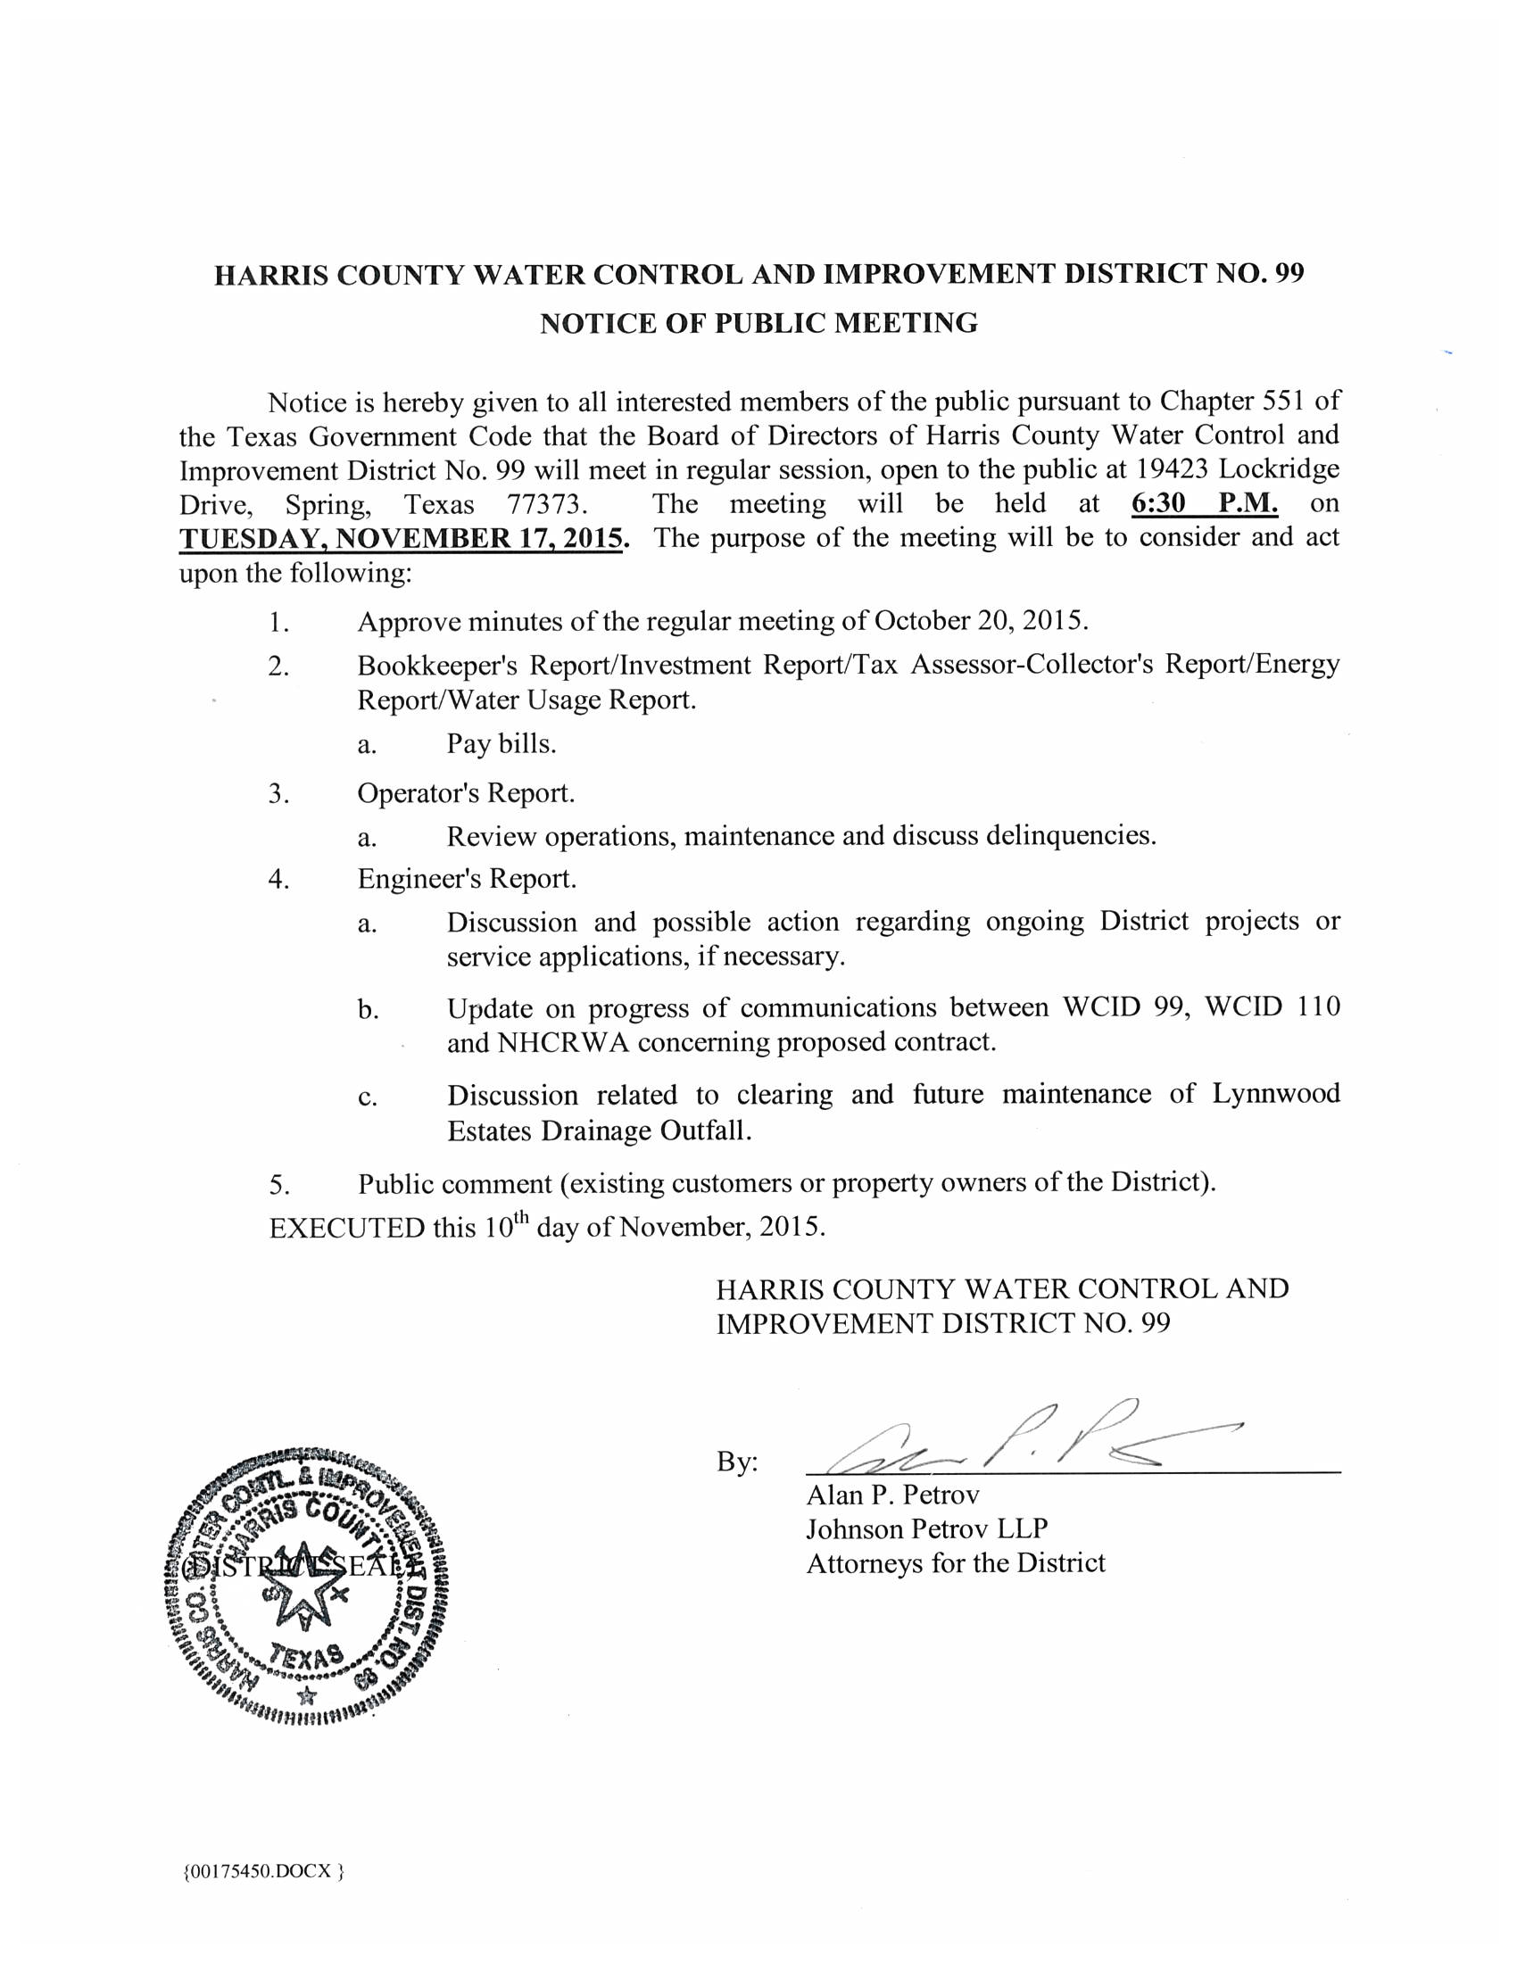

(DISTRICT SEAL)
EXHIBIT "B"

POLLING LOCATION
19423 Lockridge Drive, Spring, Harris County, Texas 77373

EARLY VOTING DATES/TIMES
Monday, October 21, 2019 thru Friday, October 25, 2019 | 2:00 pm to 5:00 p.m.
Monday, October 28, 2019 thru Friday, November 1, 2019 | 2:00 pm to 5:00 p.m.
[except Saturday, Sunday, and holidays]

ELECTION DAY HOURS
Tuesday, November 5, 2019 from 7:00 a.m. to 7:00 p.m.

